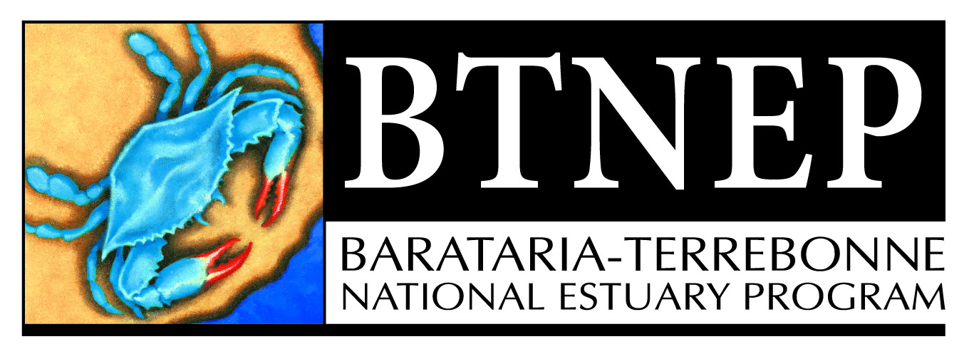

Barataria-Terrebonne National Estuary Program
Management Conference Agenda - Meeting #97
Thursday, November 4, 2021
Virtual Zoom Meeting
9:30 am to 11 am

Call to Order
- Welcome and Opening Remarks from the Chair - Quenton Fontenot, MC Chair
- Roll Call - Nicole Babin, BTNEP Office Coordinator
- Approval of the Minutes from MC #96 of August 5, 2021
Director’s Report – T. Bradley Keith
- Agenda Review – Moving forward in the aftermath of Ida
- Program Update
Team Updates – Staff Updates
- Upcoming Project Award Process – Andrew Barron, Senior Scientist
- Plant Production Facility Update – Matt Benoit, Habitat Restoration Coordinator

Partner Presentations
- Hurricane Ida Updates from The Levee Districts:
  - Terrebonne Levee District – Reggie Dupre
  - North Lafourche Levee District – Dwayne Bourgeois
  - South Lafourche Levee District – Windell Curole
- Raymond “Mac” Wade - Port of Morgan City
“Atchafalaya River Beneficial Use”
Project Spotlight-
- Dr. Veronica Manrique -
“Implementation of biological control of air potato vine in Louisiana: Project outcomes and updates”
Other Business

Upcoming Management Conference Meetings – Proposed Dates
- February 10, 2022
- May 12, 2022
- August 11, 2022
- November 10, 2022

Media Coverage - Presented for review
- “New park at Port Fourchon offers kayakers a place to paddle,” – August 19, 2021 houmatoday.com (Houma, LA) https://www.houmatoday.com/story/news/2021/08/20/coastal-wetlands-park-port-fourchon-offers-kayakers-place-paddle/8194628002/
- “Barataria-Terrebonne National Estuary Program (BTNEP) Green Team Aims to Help Louisiana Waterways,” – August 19, 2021 HoumaTimes.com (Houma, LA) https://www.houmatimes.com/news/barataria-terrebonne-national-estuary-program-btnep-green-team-aims-to-help-louisiana-waterways/

Adjourn

