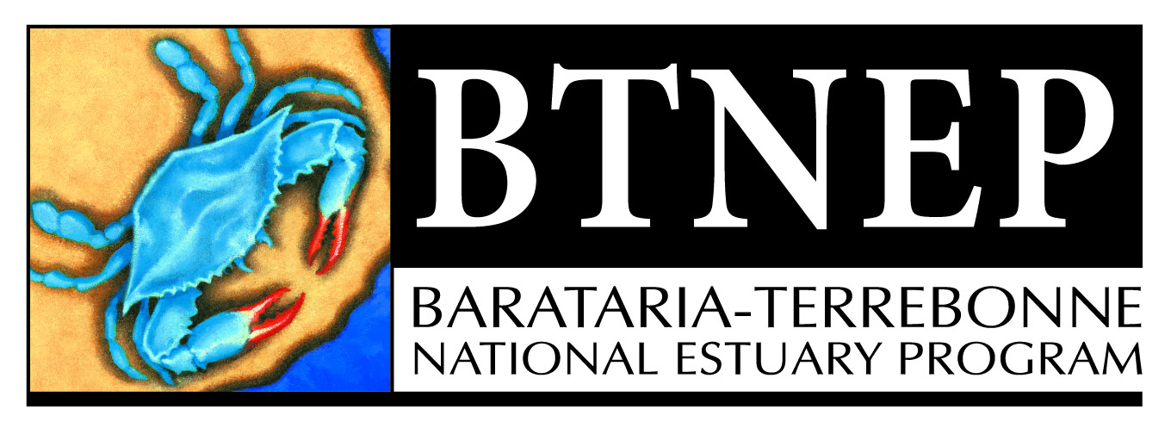

Barataria-Terrebonne National Estuary Program
Management Conference Agenda - Meeting #86
9:30 a.m. – 12:00 pm Thursday, February 7, 2019
Nicholls State University
Century Room, Nicholls Campus (Near Stadium)

- CALL TO ORDER - 9:30 A.M. – 9:40 A.M.
- Welcome – Quenton Fontenot, BTNEP MC Chairman
- Roll Call – Nicole Babin, BTNEP Office Coordinator
- Reading and Approval of Minutes – May 3, 2018 Meeting

- PROGRAM ACTIVITIES - 9:40 A.M. – 9:50 A.M.

- Personnel Changes –

- BTNEP Meeting Report – October 15, 2018 thru January 20, 2019
- Alma attended the Bayou Lafourche Fresh Water District meetings
- Michael attended the C-LEARN Leadership Council meeting
- Siva and Andrew attended a meeting with National Park Service to discuss the Citizen Science Project
- Delaina attended the Louisiana Ornithological meeting and presenting on Evaluation of Bird Nesting Use on Substrate Enhanced Beach Habitat
- Susan attended TEACHING FOR EXCELLENCE: A WYES COMMUNITY FORUM
- Susan, Nicole, Dean, Michael, and Matt attended the CAMO Group meeting
- Alma attended the Louisiana Recycle meetings
- Siva attended The Water Research webinar “Water Reuse and Reclaimed Water”
- Delaina attended the Wilson’s Plover working group meeting
- Susan, Nicole, Dean, Michael, and Matt attended the BTNEP Coastal Geology & Restoration Planning meetings
- Matt attended the Terrebonne Coastal Zone Management meeting
- Susan and Dean attended a close out meeting with Heidi Boudreaux, LUMCON
- Susan attended a meeting with Layan Tung, ES&H
- Natalie attended the Center for Bayou Studies at Nicholls
- Susan attended a meeting with Maida Owens, LA Department of Culture Recreation and Tourism
- Siva attended the EPA’s Safe and Sustainable Water Resources Webinar
- BTNEP Staff attended a meeting with Robert Twilley to discuss FIAW
- Susan attended the Annual Davis Pond Interagency Advisory Committee meeting
- Susan, Dean, Delaina, Richard, and Natalie attended meetings with Guillaume Riecuau, LUMCON to talk about possible bird research partnerships and funding opportunities
- Richard and Michael attended the CPRA 2023 Master Plan meeting in Terrebonne and Barataria respectively
- Susan and Dean attended a meeting with Kevin Belanger to discuss IT support and GOMP Grant
- Andrew attended Kristen Chatelien thesis defense at Nicholls State University
- Richard attended a meeting with Bill Fontenot to discuss the possible addition to the existing Audubon manuscript and look at developing a publication
- Susan attended a meeting with Cody Blanchard White Car Marketing to discuss media support
- Andrew and Siva attended a meeting with Ben Malbrough, Bayou Lafourche Freshwater District to discuss the Water Quality Project
- Andrew and Siva attended a National Park Service Interagency committee meeting with LDEQ
- Susan and Dean attended a meeting with Ben Malbrough, Bayou Lafourche Freshwater District
- Susan and Dean attended a meeting with Nicki Boudreaux to discuss Strategic Communications plan
- Dean and Matt attended the BTNEP and Port Fourchon restoration discussion
- Alma attended a WETSHOP Planning meeting
- Dean, Susan, Andrew and Siva attended a Bayou Folse meeting with Ducks Unlimited and NRCS
- Delaina attended a meeting with Darrin Lee, CPRA
- Susan and Nicole attended a meeting with Laure Kasovich, webmaster
- Susan attended a meeting with Cody Blanchard and Emily Knoblock White Car Marketing
- Susan, and Alma attended a meeting with Timothy Bush, LA Cajun Coast Tourism
- Alma attended a meeting with Nicki Boudreaux to discuss Bayou Lafourche Cleanup

- Presentations/Exhibits/Field Trips/ Volunteer Events – October 15, 2018 thru January 14, 2019
- Delaina, Richard and Natalie conducted the Piping Plover Surveys
- Delaina conducted Red Knot Surveys
- Andrew and Siva conducted the Bayou Folse Water Sampling events
- Alma and Delaina conducted the Marine Debris Education Prevention Programs at Elmer’s Island
- Andrew and Siva lead the ULL Wetland Soils Field Trip
- Siva exhibited at Rougarou Festival
- Susan and Dean attended the 2018 ES&H Golf Tournament Fundraiser for BTEF
- Alma attended the LSTA Conference in Shreveport
- Susan and Alma attended the Louisiana Sea Grant Coastal Connections Competition
- Alma and Siva exhibited at Ocean Commotion in Baton Rouge
- Michael participated in the Apple Snail Project site visit with Dr. Jacoby Carter, USGS
- Andrew and Siva exhibited at the Swamp Stomp Festival
- Seth exhibited at the Cajun Fly-In
- Matt conducted the Sand Live Oak Acorn Collection
- Delaina presented at the Master Naturalists Grand Isle Shorebird Interpretation
- Andrew presented at the Barrier Island workshop Louisiana Master Naturalists New Orleans
- Susan and Dean attended EPA Field Visit to BA 34-2 Hydrologic Restoration and Vegetative Plantings in the Des Allemands Swamp
- Seth and Matt hosted the Cub Scouts potting at Nicholls Farm
- Andrew, Siva, and Michael presented at the Coastal Restoration workshop for Louisiana Master Naturalists in New Orleans
- Andrew and Siva attended the Sewage Treatment System Maintenance Class
- Alma and National Park Service hosted the Marine Debris Education Prevention Program for juniors and seniors
- Seth and Matt hosted the LA Sea Grant Paddle Trip
- Alma judged at the Terrebonne Parish Science and Engineering Fair
- Michael presented at the Ben Franklin High School Career Day
- Michael, Andrew and Siva attended the Louisiana Master Naturalist Intro Workshop

III MEDIA COVERAGE (From October 15, 2018 – January 14, 2019)
- “Biology Club members brave the cold to help the Barataria-Terrebonne National Estuary Program conduct a debris…,” – January 8, 2019 Daily Comet (Thibodaux, LA)
- “Volunteers needed for local crab trap cleanup,” – December 27, 2018 Daily Comet (Thibodaux, LA)
- ”Volunteers needed for local crab trap cleanup,” – December 27, 2018 Courier (Houma, LA)
- “Volunteers sought for Thibodaux Christmas Bird Count,” – December 20, 2018 Daily Review (Morgan City, LA)
- “Volunteers needed for local crab trap cleanup,” – December 19, 2018 Daily Comet (Thibodaux, LA)
- “Volunteers needed for local crab trap cleanup,” – December 18, 2018 DailyComet.com (Thibodaux, LA)
- “Preserve our Waters for Future Generations,” – November 2018 LouisianaSportsman.com
- “Oak Grove Junior Beta Club learns about coastal land loss issues,” – November 7, 2018 TheAdvocate.com (Baton Rouge, LA)
- “Coastal workforce event held for local students,” – October 16, 2018 Daily Comet (Thibodaux, LA)

- PROJECT STATUS
- Request for Payment - “BTNEP Microplastic Curricula Development” EPA Grant Number CE-00666010 EPA Tracking 2014-30 – Alma Robichaux
- Request for Contract - “Pre-lease baseline data on plant demography of Chinese tallow before Biocontrol Program is initiated” EPA Grant Number CE-00666014 EPA Tracking 2018-15 – Michael Massimi
- Request for Payment and Final Deliverable - “Feral Hog Abatement & Removal of Invasive Vegetation In Forested Wetlands” EPA Grant Number CE-00666012 EPA Tracking 2016-26 – Michael Massimi
- Request for Payment - “Invasive Plant Management on Grand Isle Properties of the Nature Conservancy” EPA Grant Number CE-00666012 EPA Tracking 2016-27 – Michael Massimi
- Request for Payment and Final Deliverable - “Passive Array of VHF Radio Telemetry Towers in The BTNEP Region” EPA Grant Number 674EP17 EPA Tracking 2017-10 – Richard DeMay
- Request for Payment – “Professional services rendered from University of Louisiana at Lafayette” EPA Grant Number 671EP16, EPA Tracking No. EPA 2016-15
- Request for Payment – “Design and Layout of the 2019 Tidal Graph Calendar” EPA Grant Number CE-00666014 EPA, Tracking No. EPA 2018-06
- Request for Payment – “Professional services rendered from University of Louisiana at Lafayette” EPA Grant Number 671EP16, EPA Tracking No. EPA 2016-15
- Request for Payment – “Design and Layout of the 2019 Tidal Graph Calendar” EPA Grant Number CE-00666014 EPA, Tracking No. EPA 2018-06
- Request for Payment and Final Deliverable – “2018 WETSHOP Louisiana Wetland Teacher Workshop” EPA Grant Number CE-00666014 EPA Tracking No. EPA 2018-10 – Alma Robichaux
- Request for Contract – “2019 WETSHOP: Louisiana Wetland Teacher Workshop” EPA Grant Number CE-00666015 EPA Tracking 2019-12 – Alma Robichaux
- Request for Contract – “Teach Wild: A Lesson on Marine Debris” EPA Grant Number CE-00666015 EPA Tracking 2019-13 – Alma Robichaux
- Request for Payment and Final Deliverable - “Creating Curriculum to accompany BTNEP’s Louisiana Floor Map and Annotated Student Atlas of Louisiana” EPA Grant Number CE-00666013 EPA Tracking 2017-12-C - Alma Robichaux

- SCHEDULE NEXT BTNEP MANAGEMENT CONFERENCE MEETING DATE –
9:50 A.M. – 9:55 A.M.
- Save the Date – May 2, 2019 – Ballroom, Nicholls State University
- Save the Date – August 1, 2019 – Plantation Suite, Nicholls State University
- Save the Date – November 7, 2019 – Plantation Suite, Nicholls State University

- OTHER IMPORTANT UPCOMING BTNEP/BTEF AND RELATED DATES –
- Bayou Lafourche Cleanup – March 23, 2019
- Paddle Bayou Lafourche – April 11-13, 2019
- Grand Isle Migratory Bird Celebration – April 12-14, 2019

- DISCUSSION ITEMS – 10:00 A.M. – 12:00 Noon
- “Louisiana Master Naturalists Helping BTNEP Educate Adults about the Value of Estuary” - Dr. Robert A. Thomas, Professor and Director of the Loyola Center for Environmental Communication School of Mass Communication ( 20 minutes)
- “Research Indicates Microplastic in More Places” - Dr. Mark C. Benfield, LSU School of the Coast and Environment Department of Oceanography and Coastal Sciences - (20 minutes)
- Marine Debris Prevention Lessons – Alma Robichaux Jackson, BTNEP and Dottie Hartman, LSU Grad Student – (25 minutes)
- “Feral Hog Survey in Terrebonne – Project Report” – Ben Hall – (25 minutes)

- New Business

- Announcements

- Adjourn

